PROJECT PROGRESS REPORT
REPORTING PERIOD: 2025

Project Summary Information
Project Title | Promoting Resilient Communities to Prevent Violent Extremism in Central Asia (PVE-2)
Project ID | 01001204
Project Duration | 1 August 2023 – 31 December 2025
Location | Uzbekistan: Tashkent, Fergana, Andijan, Namangan, Surkhandarya
CPD/UNSDCF/RPD/SP Outputs | UNDSDCF Outcome: 1.3  CPD Outcome: 1.1  UNDP Strategic Plan Outcome: 1  Output Number: 1 and 2
Gender marker | GEN 2
Digitalization marker | N/A
Implementing Partner (s) | The Youth Agency of Uzbekistan, The Ministry of Foreign Affairs, The Administrations of Surkhandarya, Fergana, Namangan and Andijan regions, IT Park of Uzbekistan, Mahalla Association, local NGOs
Total budget | 687 442,12
Donors (funding sources) | The Government of Japan
Budget (annual budget) | 468 475,03
Expenditure recorded for the reporting period | 465 859,62
Expenditure recorded for the total project | 681 826,71 (99,6 delivery rate in total)
Project Manager name: | Mr Sarvar Tursunov

1. Executive Summary
Uzbekistan is a doubly landlocked country in Central Asia and the most populous in the region, with more than 37 million people — almost half of Central Asia’s total population. It is marked by significant linguistic and religious diversity and a long-standing tradition of peaceful coexistence. In line with the UN Global Counter-Terrorism Strategy, the country has adopted a range of measures to address the underlying drivers of violent extremism and terrorism.
Despite these initiatives, certain extremist threats persist, primarily linked to the spillover of ISIS-K activities from neighboring Afghanistan and to online radicalization targeting young people. In response, Uzbekistan has intensified efforts to restrict the spread of extremist content. In 2025 alone, authorities banned numerous sources of such materials, including hundreds of social media accounts, messaging channels, video platforms, and websites. The current list includes 220 Facebook pages, 709 Telegram channels and groups, 239 Instagram profiles, 104 YouTube channels, 46 TikTok accounts, and 40 websites, among others.
UNDP in Uzbekistan has played a central role in supporting the government’s implementation of priority actions under the “National Strategy to Counter Terrorism and Extremism for 2021–2026.” As part of these ongoing efforts, the project “Promoting Resilient Communities to Prevent Violent Extremism in Central Asia (PVE-2)” was launched to complement national initiatives and create synergies with key policy frameworks, including the “Uzbekistan–2030” Strategy and the 2024 State Programme for the Year of Support for Youth and Business.
The project aims to strengthen the resilience of young people and communities by building effective partnerships between the private sector and youth, with a particular focus on vulnerable groups. Funded by the Government of Japan, the initiative is implemented across Kazakhstan, the Kyrgyz Republic, Tajikistan, Turkmenistan, and Uzbekistan, ensuring regional coverage and the sharing of best practices and lessons learned. In Uzbekistan, the project intended to reach 2,525 beneficiaries. Of these, 1,500 young women and men receiving training sin vocational, digital, and soft skills, while at least 700 participants were expected to gain employment opportunities through cooperation with private sector partners. Youth centers, legal clinics, and advisory groups were planned to be established in four pilot regions, including remote areas, to provide legal and psychosocial support to more than 500 vulnerable young people. These platforms ere expected to help strengthen community dialogue and enhance youth participation in decision-making processes.
The project also sought to build the capacity of 25 local authorities through specialized trainings on conflict prevention, inclusive planning, and equitable resource allocation. More than 100 officials are planned to be equipped with the skills needed to identify and respond effectively to early signs of violent extremism.
Gender sensitivity is a crosscutting priority of the project, with a strong focus on engaging women and young people in local policy development, thereby fostering social cohesion and contributing to sustainable development.
During the reporting period, the project continued to make steady progress towards its established targets and expected outcomes.
Earlier, the project delivered trainings for 400 young people in Fergana and Andijan — target regions. These interventions focused on developing modern, market-relevant skills — such as social media marketing, freelancing in domestic and international markets, digital sales and services, and the basics of network engineering and internet technologies — to support decent employment of the trainees. In 2025, analogues trainings were delivered for more than 250 young people in the Namangan region.
The project also strengthened the capacities of 550 young people in Fergana through soft skills development, including critical thinking, time management, emotional intelligence, the use of artificial intelligence and ChatGPT in the workplace, teamwork and communication culture, and job search skills.
To promote self-employment and entrepreneurship among women, the project introduced specialized financial literacy trainings. These covered financial planning, setting financial goals, efficiency and risk assessment, saving opportunities in small businesses, and managing income and expenses. More than 300 young people in the Namangan region participated in these workshops.
Additionally, UNDP supported the organization of a Job Fair in Fergana to connect young people with employment opportunities. The event brought together over 25 local companies and 300 job seekers, resulting in employment or internship placements for 77 participants.
In 2024, the project established a Youth Hub in Termez in partnership with Termez State University. To date, more than 300 individuals have benefited from its legal clinic services and mental health and psychosocial support. In 2025, three additional youth hubs were launched in Fergana (“Tashlak Youth Hub”), Namangan (“Turakurgan Youth Hub”), and Andijan (“Khanabad Regional Youth Hub”). Located in a border area, the Khanabad Regional Youth Hub is designed to serve not only Uzbek citizens but also individuals from neighboring countries. The opening ceremonies of the Turakurgan and Khanabad hubs were held in cooperation with the Embassy of Japan in Uzbekistan.
The project also enhanced the capacities of 360 community leaders — including mahalla chairs, women activists, and community nurses—in Fergana (including border districts such as Sokh and Fergana), Andijan, and Namangan regions. These trainings addressed psychosocial support, planning and implementation of social projects, professional development of social workers, and monitoring the effectiveness of social assistance.
A key component of the project was the delivery of specialized trainings on the prevention of extremism and radicalization for government officials in Fergana, Andijan, Namangan, and Surkhandarya regions. These activities were implemented jointly by UNDP and the International Islamic Academy under the Committee for Religious Affairs of the Republic of Uzbekistan.
In total, for the whole period of the implementations, the project established 4 operational youth hubs, had far over 3155 beneficiaries; The project provided the employment of over 800 young people from the vulnerable groups in the remote areas; benefited over 250 mahallas and 28 local authorities.

- Progress Review

- Key results achieved
Violent extremism is a multifaceted challenge, and its prevention requires promoting positive change across multiple, interconnected levels while ensuring that interventions are mutually reinforcing. Equally important is sustained investment in inclusive engagement among all stakeholders involved in preventing violent extremism (PVE) at both national and community levels, built on dialogue, trust, and cooperation to secure effective and lasting results. Guided by this approach, the project concentrated on strengthening three core pillars of resilience to violence.
At the community level: Young people in Uzbekistan have traditionally been excluded from discussions and decision-making on PVE, often viewed merely as targets of interventions rather than active participants. Given the country’s predominantly young population, it is essential to recognize and invest in the potential, capacities, and resilience of youth by engaging them as equal partners in policymaking, programming, and research. The project therefore placed young people at the center of prevention efforts, recognizing them as key stakeholders in both short - and long-term strategies to counter violent extremism.
At the institutional level: The second pillar focused on strengthening national capacities by supporting central and local authorities, community leaders, frontline service providers, civil society organizations, and faith-based actors. By reinforcing national prevention ecosystems, the project sought to build durable resilience that enables societies to respond effectively to both current and emerging risks of violent extremism. UNDP’s interventions emphasized investments in physical and social infrastructure, as well as institutional capacity to deliver inclusive prevention approaches, ensuring national ownership and long - term sustainability.
At the structural level: Regional cooperation is essential for addressing the cross-border nature of violent extremism and enhancing collective prevention capacities. While violent extremism is a global phenomenon, it manifests differently across local and regional contexts, each with distinct risks and opportunities. As Uzbekistan continues to refine its own prevention approaches in line with international standards and lessons learned, the project supported the creation of platforms for exchanging experiences among local, regional, and international stakeholders. Such collaboration is a key contributor to strengthening regional resilience.
Under Output 1, the project created platforms that link the private sector with young people to deliver skills training and facilitate access to sustainable employment opportunities. It also established mechanisms to provide legal and psychosocial support for vulnerable youth in remote areas through the construction and renovation of youth hubs and legal clinics.
To be more precisely, in general, over 1,100 young people were trained (400 - in 2024) in employment skills, with over 700 of them gaining employment or becoming self-employed. Three youth hubs were launched to operating the target regions with over 500 beneficiaries. These hubs offer thematic and skills trainings and seminars to improve foreign language proficiency, free legal aid, psychological aid, and business development programs led by experienced trainers to foster entrepreneurial skills and support youth start-ups.
In 2024, trainings were organized for the youth in Fergana and Andijan, covering 400 people (over 35% - females, 38%- people with disabilities). The trainings aimed at equipping the youth with the modern skills (social media marketing, freelancing in the international and domestic markets, digital sales and services, basics of network engineering and internet technologies) to facilitate their decent employment. In 2025, analogues trainings were held for over 250 young people in Namangan region (over 40 % - females, 14%- people with disabilities).
The project built the capacities of the 550 young people in Fergana on soft skills, which contained critical thinking, time management, emotional intelligence, applying artificial intelligence and Chat GPT in work, understanding of teamwork and communication culture, job search skills etc. Moreover, to foster the self-employment and entrepreneurship amongst the women, the project launched the special trainings on developing financial literacy that contains such topics as financial planning, determination of financial goals, efficiency and financial risk assessment, opportunities to save funds in small business, income and expenses in small business. These workshops covered over 300 young people in Namangan region (42% - females and 58% - males, this facilitated 152 of the participants to be self-employed/employed).
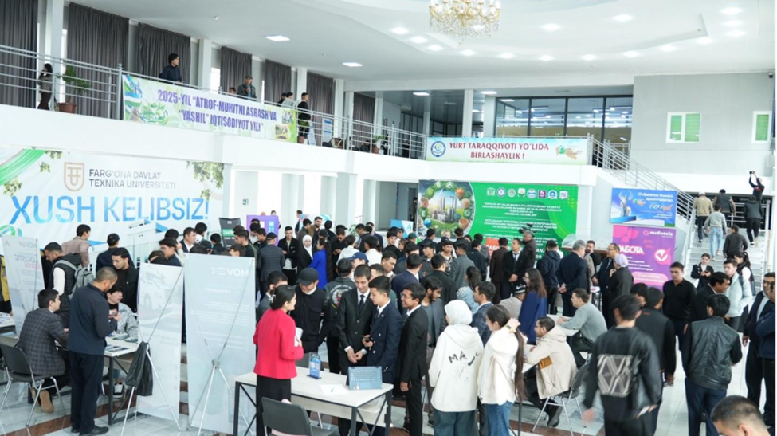
In the reporting period, project in cooperation with the national partners facilitated the Job Fair in Fergana to provide them with employment opportunities. Over 25 local companies and 300 young job seekers took part in the event. 77 people found employment (including internships).
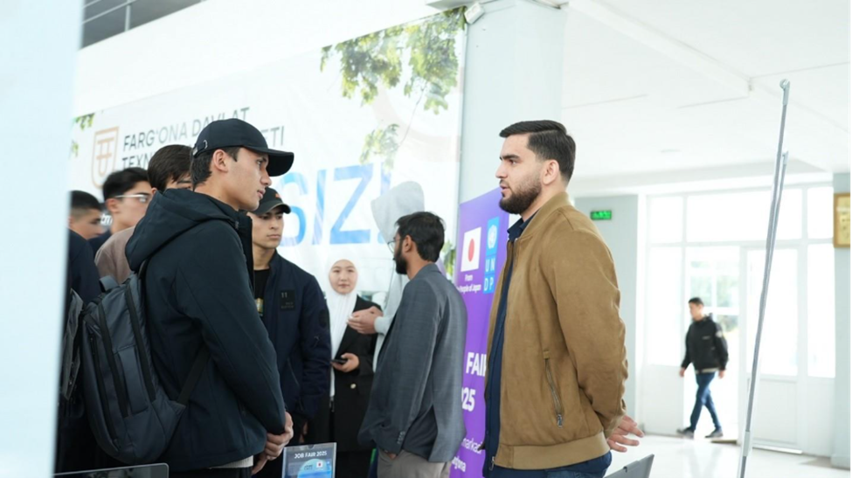

In cooperation with the NGO Centre for Developing Women’s Entrepreneurship the project introduced specialized financial literacy trainings in Namangan. These covered financial planning, setting financial goals, efficiency and risk assessment, saving opportunities in small businesses, and managing income and expenses. More than 300 young people in the Namangan region participated in these workshops.
In 2025 the project established three youth hubs in Fergana (“Tashlak Youth Hub”), Namangan (“Turakurgan Youth Hub”) and Andijan (“Khanabad Regional Youth Hub”). The “Khanabad Regional Youth Hub”, which is located in the border area is planned to provide services for not only Uzbek citizens, but also ones of the neighboring countries. The opening ceremonies of “Turakurgan Youth Hub” and “Khanabad Regional Youth Hub” took place in November 20 in cooperation with the Embassy of Japan in Uzbekistan.
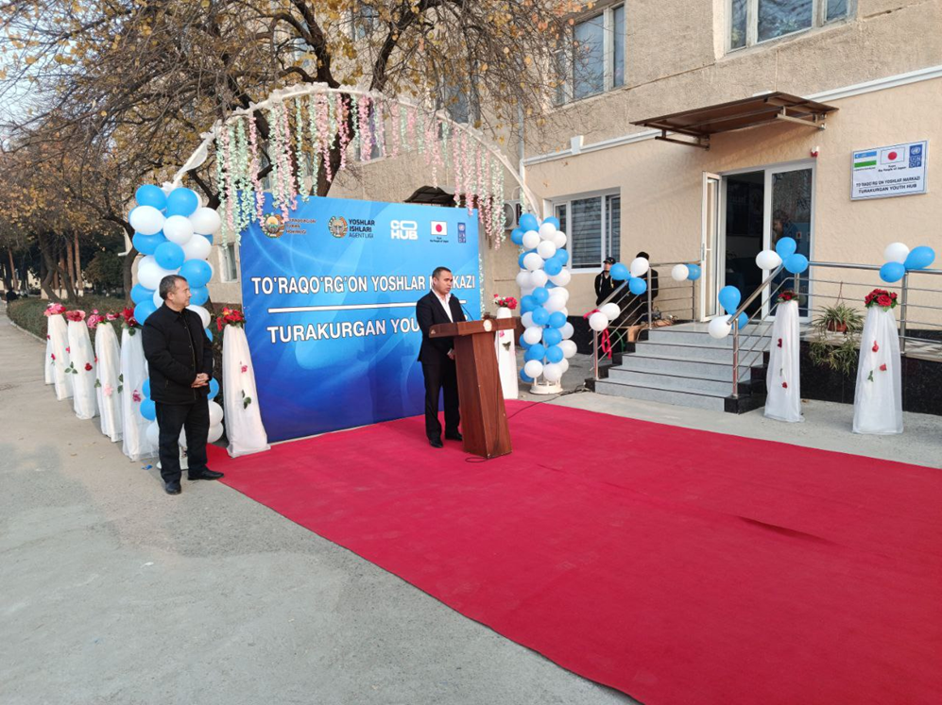

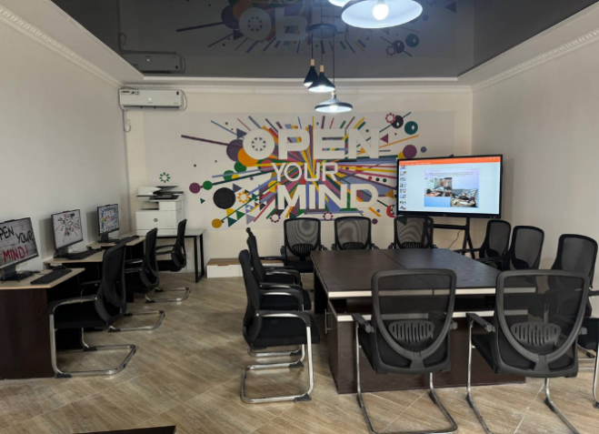

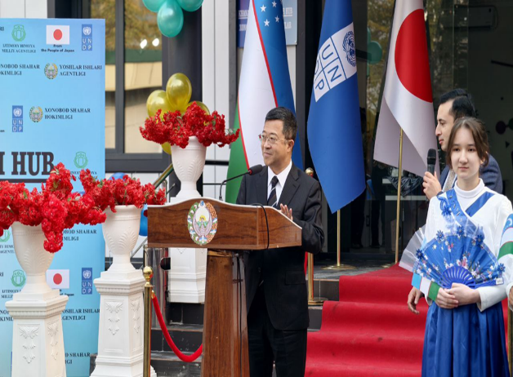

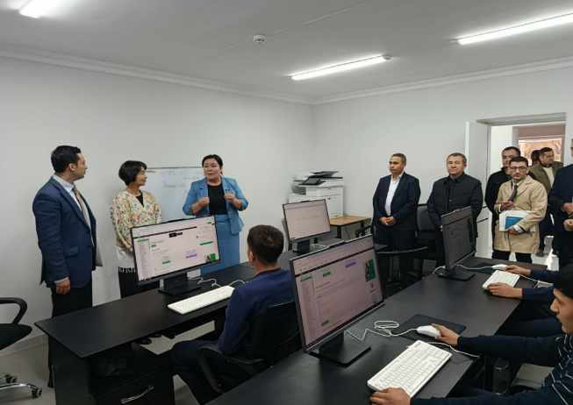

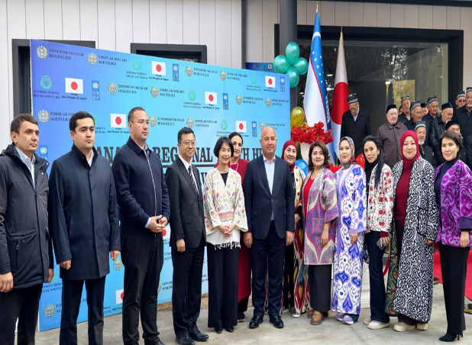

Under Output 2, the project strengthened the capacities of local authorities to identify and respond to early signs of conflict while fostering social cohesion. In addition, it enhanced the capacity of pilot communities (mahallas) to adopt gender - sensitive decision-making, recognize early conflict indicators, and implement policies that reflect local needs and priorities, with particular attention to vulnerable women and young people.
In precise terms, In general over 1000 community leaders and 100 of government officials in the target regions were trained on prevention skills.
In 2025, in cooperation with the local NGO “Barqaror Hayot” and the Ministry of Internal Affairs the special capacity building workshops were organized on supporting social cohesion in the target regions: Surkhandarya, Fergana, Andijan and Namangan. The trainings upskilled the community (mahalla) leaders and MIA representatives (over 720 people) on prevention and participatory planning with mahalla institution covering such topics as conceptual analysis of the “safe mahalla”, the role of the preventive measures in supporting the social cohesion in mahallas, including the preventing violent extremism and radicalization amongst the youth, terminological analysis of the concepts of extremism and terrorism, principles of organizing rehabilitation work with vulnerable groups, including the persons repatriated from conflict zones, a gender-sensitive approach to preventing violent extremism, understanding the impact of gender stereotypes on vulnerability to radicalization; involving women and youth in preventive measures etc.
In 2024-2025, the project built capacities of 360 community leaders, including mahalla chairs, women activists and community nurses, on social work Fergana (border regions - Sokh and Fergana districts), Andijan and Namangan regions. The trainings covered the session on psychosocial work, planning and implementation of the social projects, professional development of the staff involved in the social work, monitoring of the efficiency of the social support etc.
In late November 2025, the project initiated the special trainings on preventing extremism and radicalization for the government staff (around 130 representatives) in Fergana, Andijan, Namangan and Surkhandarya. It is a cooperation between UNDP and International Islamic Academy under the Committee for Religious Affairs of the Republic of Uzbekistan. The covered such topics as fundamentals of critical thinking and spiritual stability to prevent radical and extremism ideas amongst the youth; threats in the media space and information security of young people (fake news, radical propaganda, and the impact of algorithms); media literacy: information selection, analysis and risk protection (critical thinking, resource evaluation, cyber security); security of migrants (recruitment methods of extremist groups, manipulation, protective measures); preventive tasks of civil servants against extremism and radicalism (social cooperation and legal mechanisms); extremist ideas under the guise of the religion, tolerance and peace in Islam (improving religious literacy and combating manipulation).
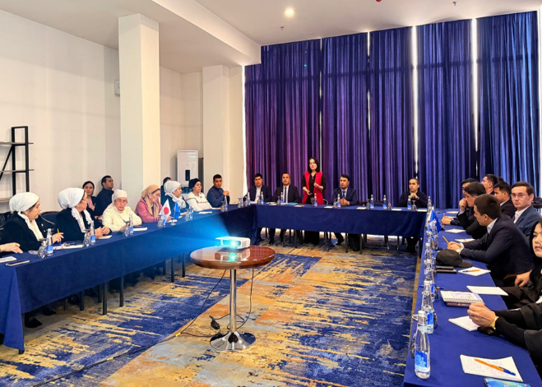

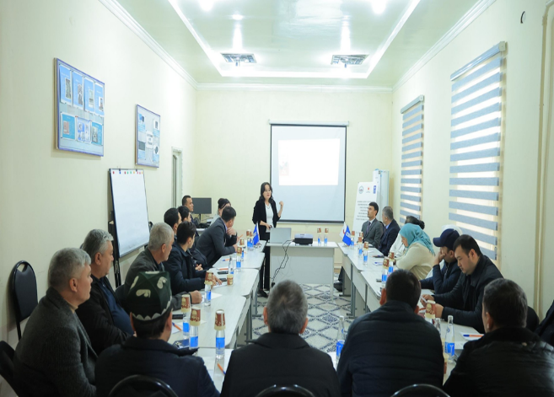

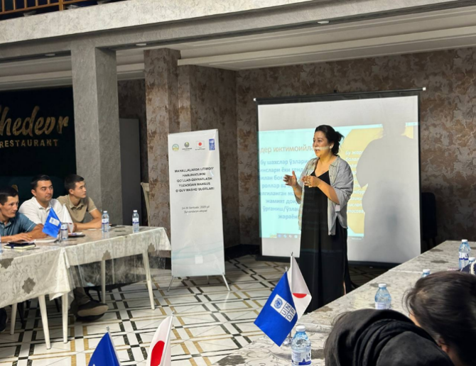

- Output progress
Progress reported against each output. Link to the last report submitted, and please mention the status of previously delayed outputs.
Output statement | Baselines  Value type | Indicators | Annual Targets | End of the project target | Status: On-track/ off-track / complete | Means of verifications and comment to substantiate the selected response
Output 1: Empowered societies with youth at the center | Baseline: 400 (2024)  Baseline: 100 (2024)  Baseline: 1 (2024)  Baseline: 0 (2024) | Indicator 1.5.1.1: # of young people received skills development training  Indicator 1.5.1.2: # of young people are employed  Indicator 1.5.2.1: # of youth hubs are set up to provide legal, psychological support to vulnerable youth  Indicator 1.5.2.2: Number of young people received  legal and physiological support through youth clinics/hubs | AWP target: 1100  AWP target: 600  AWP target: 3  AWP target: 500 | Reporting period: 1405  Cumulative total: 1805  Reporting period: 705  Cumulative total: 805  Reporting period: 3  Cumulative total: 4  Reporting period: 500  Cumulative total: 500 | Completed | Project monitoring reports
Output 2: Strengthened national capacities for prevention and social cohesion | Baseline: 0 (2024)  Baseline: 120 (2024) | Indicator 2.5.1.: the number of local government representatives are equipped with skills and knowledge on conflict prevention mechanisms and service provision to prevent conflicts and violent extremism  Indicator 2.5.2.: # of young people and women in pilot communities improved their capacities to make gender-sensitive decisions, detect early signs of conflict, and implement policies considering the needs of the local communities. | AWP target: 100  AWP target: 880 | Reporting period: 130  Cumulative total: 130  Reporting period: 918  Cumulative total: 1038 | Completed | Project monitoring reports

- Communications, visibility, and partnerships

The project continued close collaboration with Association of Mahallas in the framework of the signed in MOU (signed in November 2024) between the Association of Mahallas of Uzbekistan and the UNDP in Uzbekistan, setting the stage for community-based activities. The MOU focuses on:
- Improving social services in mahallas through administrative reforms, digital transformation, and case management;
- Supporting youth employment, particularly for vulnerable groups;
- Recommending improvements to legislation and services for vulnerable populations, including people with disabilities and returnees from conflict zones;
- Enhancing staff capacity through training;
- Collaborating on preventing violent extremism and youth radicalization in at-risk communities.
Moreover, the project facilitated the partnership of UNDP with the International Islamic Academy under the Committee of the Religious Affairs. As a result, the Academy became the major national partner in organizing the special trainings on preventing the violent extremism for the representatives of the local authorities, such as local Khokimiyats, youth affairs agency, Ministry of Internal Affairs, Committee on Women’s Affairs, Ministry of Justice and etc. (around 130 participants).

Visibility:

- https://www.undp.org/uzbekistan/press-releases/bridge-tomorrow-regional-youth-hub-opens-andijan-unite-central-asias-youths
- https://www.undp.org/uz/uzbekistan/press-releases/kelajak-uchun-koprik-andijonda-markaziy-osiyo-yoshlari-uchun-mintaqaviy-yoshlar-markazi-ochildi
- https://t.me/i_himoya_and/6462
- https://t.me/i_himoya_and/6449
- https://www.undp.org/ru/uzbekistan/press-releases/most-v-budushchee-v-andizhane-otkrylsya-regionalnyy-molodyozhnyy-centr-prizvannyy-obedinit-molodyozh-centralnoy-azii
- https://www.undp.org/uz/uzbekistan/press-releases/kelajak-uchun-koprik-andijonda-markaziy-osiyo-yoshlari-uchun-mintaqaviy-yoshlar-markazi-ochildi
- https://www.undp.org/uz/uzbekistan/press-releases/kelajak-uchun-koprik-andijonda-markaziy-osiyo-yoshlari-uchun-mintaqaviy-yoshlar-markazi-ochildi
- https://t.me/unuzbekistan/4639
- https://t.me/undpuzbekistan/7446
- https://www.instagram.com/p/DRUDnDAD-uV/?img_index=1
- https://www.facebook.com/UNDPUzbekistan/posts/pfbid02aPDB6f4MYujWWuNf1adGJMj2SUYXcaXhfqDsdxxomH57tnJktZgyys3A3T1GHvAyl
- https://www.undp.org/uzbekistan/press-releases/turning-energy-action-ferganas-youth-hub-takes
- https://www.undp.org/uzbekistan/press-releases/launch-termez-youth-hub-new-initiative-empowering-youth-surkhandarya-region
- https://iiau.uz/oz/news/4328
- https://www.undp.org/ja/japan/press-releases/bridge-tomorrow-regional-youth-hub-opens-andijan-unite-central-asias-youths

- Project risks and mitigation measures
 | Description | Date identified | Impact /Priority | Countermeasure /MNGT Response | Owner | Status
1. | Government re-structuring – changes in key Ministries, departments and agencies; changes in high level decision-makers and technical staff | 31.08.2023 | Impact on timely project delivery | Project management will be in constant contact with all parties involved to ensure stakeholder engagement, all project activities are endorsed by national partners and all pending issues are timely addressed. | Sarvar Tursunov, Project Manager | Closed
2. | Security and political sensitivities may impede access to local communities in regions and non-governmental actors | 30.09.2023 | Impact on engaging local communities and civil society actors in project activities in regions | Project management will be in constant contact with all parties involved to ensure stakeholder engagement, all project activities are endorsed by national partners and all pending issues are timely addressed. | Sarvar Tursunov, Project Manager | Closed
3. | Lack of support by the partner countries for P/CVE sensitive activities | 30.09.2023 | Project implementation and achieving project outcomes and expected results | Project management will keep awareness on the sensitive issues related to the project activities to be implemented with the involved countries and resolve them with consultations and taking into account the priorities of the project. | Sarvar Tursunov, Project Manager | Closed
4. | Potential delays of project activities and implementation due to extended reviews and clearances of action plans, or provision of contribution/support by national partners | 30.09.2023 | Impact on timely and quality realization of project actions and objectives | Project management will be in constant contact with national partners and all issues are timely addressed in consultation with them. | Sarvar Tursunov, Project Manager | Closed

- Lessons Learned
Document any lessons that will be applied to address challenges or improve the implementation pace. Outline any good practices, as applicable.
The experience demonstrated that derivative activities — such as the outcomes of youth hub activities and the employment of young people — required significantly more time than was originally anticipated. These activities could not progress independently, as they depended on the successful completion of other planned interventions. As a result, delays in earlier activities directly affected the timeline for these derivative components. This highlighted the need for more realistic scheduling and sequencing. For future phases of the project, it is recommended that additional time be allocated to accommodate these dependencies and ensure effective implementation.

- Way Forward

Building on the project’s achievements, the establishment of the Youth Hub in Termez in partnership with Termez State University created a strong foundation for expanding similar initiatives nationwide. This momentum enabled the launch of additional youth hubs, including the Tashlak Youth Hub in Fergana in cooperation with the Youth Affairs Agency and IT Park; the Turakurgan Youth Hub in Namangan, developed with Turakurgan College, the NGO “Centre for Developing Women’s Entrepreneurship,” and the Namangan Khokimiyat; and the Khanabad Regional Youth Hub in Andijan, implemented in partnership with the Youth Affairs Agency, the “Inson” Center under the Agency of Social Protection, and the Republican Center for Social Adaptation of Children.
Strategically located in a border area, the Khanabad Regional Youth Hub is positioned to serve both Uzbek youth and young people from neighboring countries. Its establishment aligns with the initiative announced by the President of the Republic of Uzbekistan at the Consultative Meeting of the Heads of State of Central Asia in Dushanbe on September 14, 2023, which called for the creation of a regional center to advance youth empowerment and self-realization across Central Asia.
Looking ahead, the hub will function as a regional platform to harness the potential of Central Asian youth, promote their active participation in addressing regional and global challenges, and strengthen cooperation and mutual understanding among countries. It is expected to bring together young leaders, researchers, entrepreneurs, and activists to jointly contribute to sustainable development and improved living standards. Central Asian citizens residing in Uzbekistan will also be able to fully benefit from the hub’s programs and services. The Khanabad Regional Youth Hub is anticipated to play a pivotal role in unifying regional efforts to enhance youth support systems, particularly in the areas of skills development, employment, and social protection.
All four youth hubs are expected to continue operating sustainably beyond the project lifecycle, supported by strong national ownership and the long-term commitment of partner institutions. During the initial phase, the project contributed to this sustainability by providing job-skills training and conducting training-of-trainers (ToT) sessions for hub personnel.
In parallel, collaboration with the International Islamic Academy through specialized trainings laid the groundwork for ongoing efforts to prevent violent extremism. To institutionalize these efforts, an agreement was reached to develop a comprehensive manual. This resource will guide future trainings, academic research, and the development of educational materials—including brochures and textbooks — for higher education institutions, as well as for use in community-based education and outreach. The manual aims to strengthen awareness and capacities among the general population, women, and youth regarding the legal and ideological foundations of preventing radicalism.
Drawing on the training results, the manual will address key themes such as critical thinking and spiritual resilience among youth; risks within the media and information space, including misinformation and radical propaganda; media literacy and cyber security; migrant safety and protection from extremist recruitment; the role of civil servants in prevention through legal and social measures; and countering extremist narratives misusing religion while promoting tolerance and peace in Islam, among other relevant topics.

Periodicity of this project progress report will be determined based on online input; it can be used quarterly, half-yearly, or annually. Once the data from this tool is input into Quantum, one can generate multi-year, annual, or quarterly reports, as the system should be able to aggregate various periods as long as they have been reported. The minimum requirement for Project Board to meet at least once to review progress and risks is annual - per policy.

